Proposal:

Idea1:

Course registration site

* Problem
  + Too much plain text
  + Students do not use timetable builder tool much
  + Search function does not support course name search
  + Timetable only shown when not viewing course info
  + Requires students to have multiple tabs open, i.e. timetable, program requirements, etc.
* Motivation
  + Hard to navigate, solve to save time and effort
  + Takes time to gathering course info
  + Target: UVic students
* Solution
  + Implement a new ui that includes:
    - Better visuals(colours), clearer to navigate
    - More interactive tools:
      * drop down menu
      * drag-and-drop courses to add and preview in timetable
      * Real time schedule/timetable
      * Pop-up course info including prerequisites/title/teacher/class(waitlist) size(remain)/enable timetable preview
      * When adding a course, a list of lab/tutorial will show up for user to select, which supports above features
      * better search engine
      * Different icons for taken courses, program required courses

The goal of the new ui is to add the following features:

* Clearer interface
  + less sub-pages, combining pages with similar functions
  + viewable timetable while in any page relating to courses (Sketch 1-1)
* Better visuals
  + visible timetable, with different borders to indicate registered(solid line), waitlisted(dashed line) or previewed course(zig-zag line) (Sketch 1-3)
  + Colors that indicate different currently registered or waitlisted courses
  + Icons that indicate taken, or program required.
    - Check mark = taken courses
    - Star = program required
    - No shape = elective
* More interactive tools
  + Drag-and-drop to add a course(Sketch 1-2)
  + Search function, where users can search by subject name and course name (i.e. Seng310) or CRN (Sketch 1-1)
  + Courses in each subject is listed under the search bar, each having its own drop-down menu that reveal its different sections (Sketch 1-2)
  + Pop-up course information including prerequisites, title, teacher, class(waitlist) size(remain) (Sketch 1-3)
  + List of subject can be revealed by a button next to search button
  + When adding a course, a list of lab or tutorial sessions will show up for the user to select, which supports timetable preview and pop-up information window

Introduction

The UVic course registration system (CRS), especially the “add or drop” and “timetable builder” pages, is hard to use and navigate through. It takes students a lot of time and effort to gather information and make decisions. Therefore, we aim to design a more interactive and convenient user interface for all students.

Problem:

Currently the CRS have the following problems:

* contains too much plain text
* search function is normally hidden
* students cannot see their timetable while looking up a course
* requires students to have multiple tabs open, i.e. timetable, program requirements, etc.

It is hard to use, and costs students too much time and effort to plan out courses in a semester.

Motivation:

Planning a semester is crucial to all students. A poorly designed CRS only complicates this process. Our goal is to reduce possible confusion caused by the current CRS, and we try to increase efficiency of information gathering and course selection.

Solution:

Our solution is to design a new user interface for the CRS. The key features associated with it are convenience, clarity and efficiency. Below are some sketches of our envisioned looks of the new CRS.

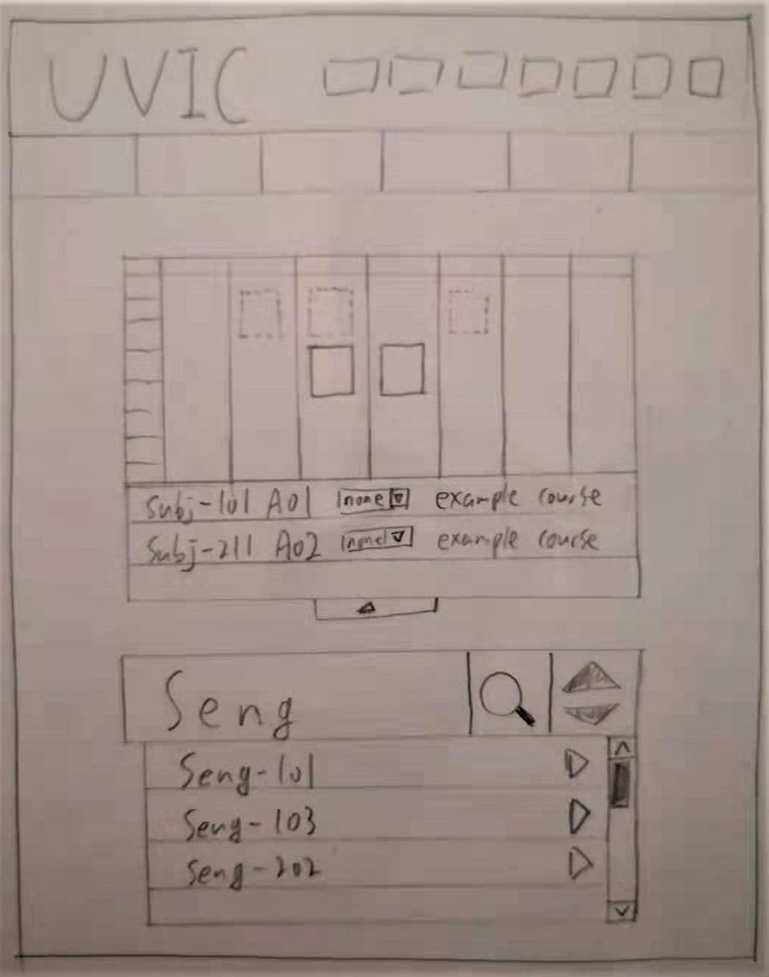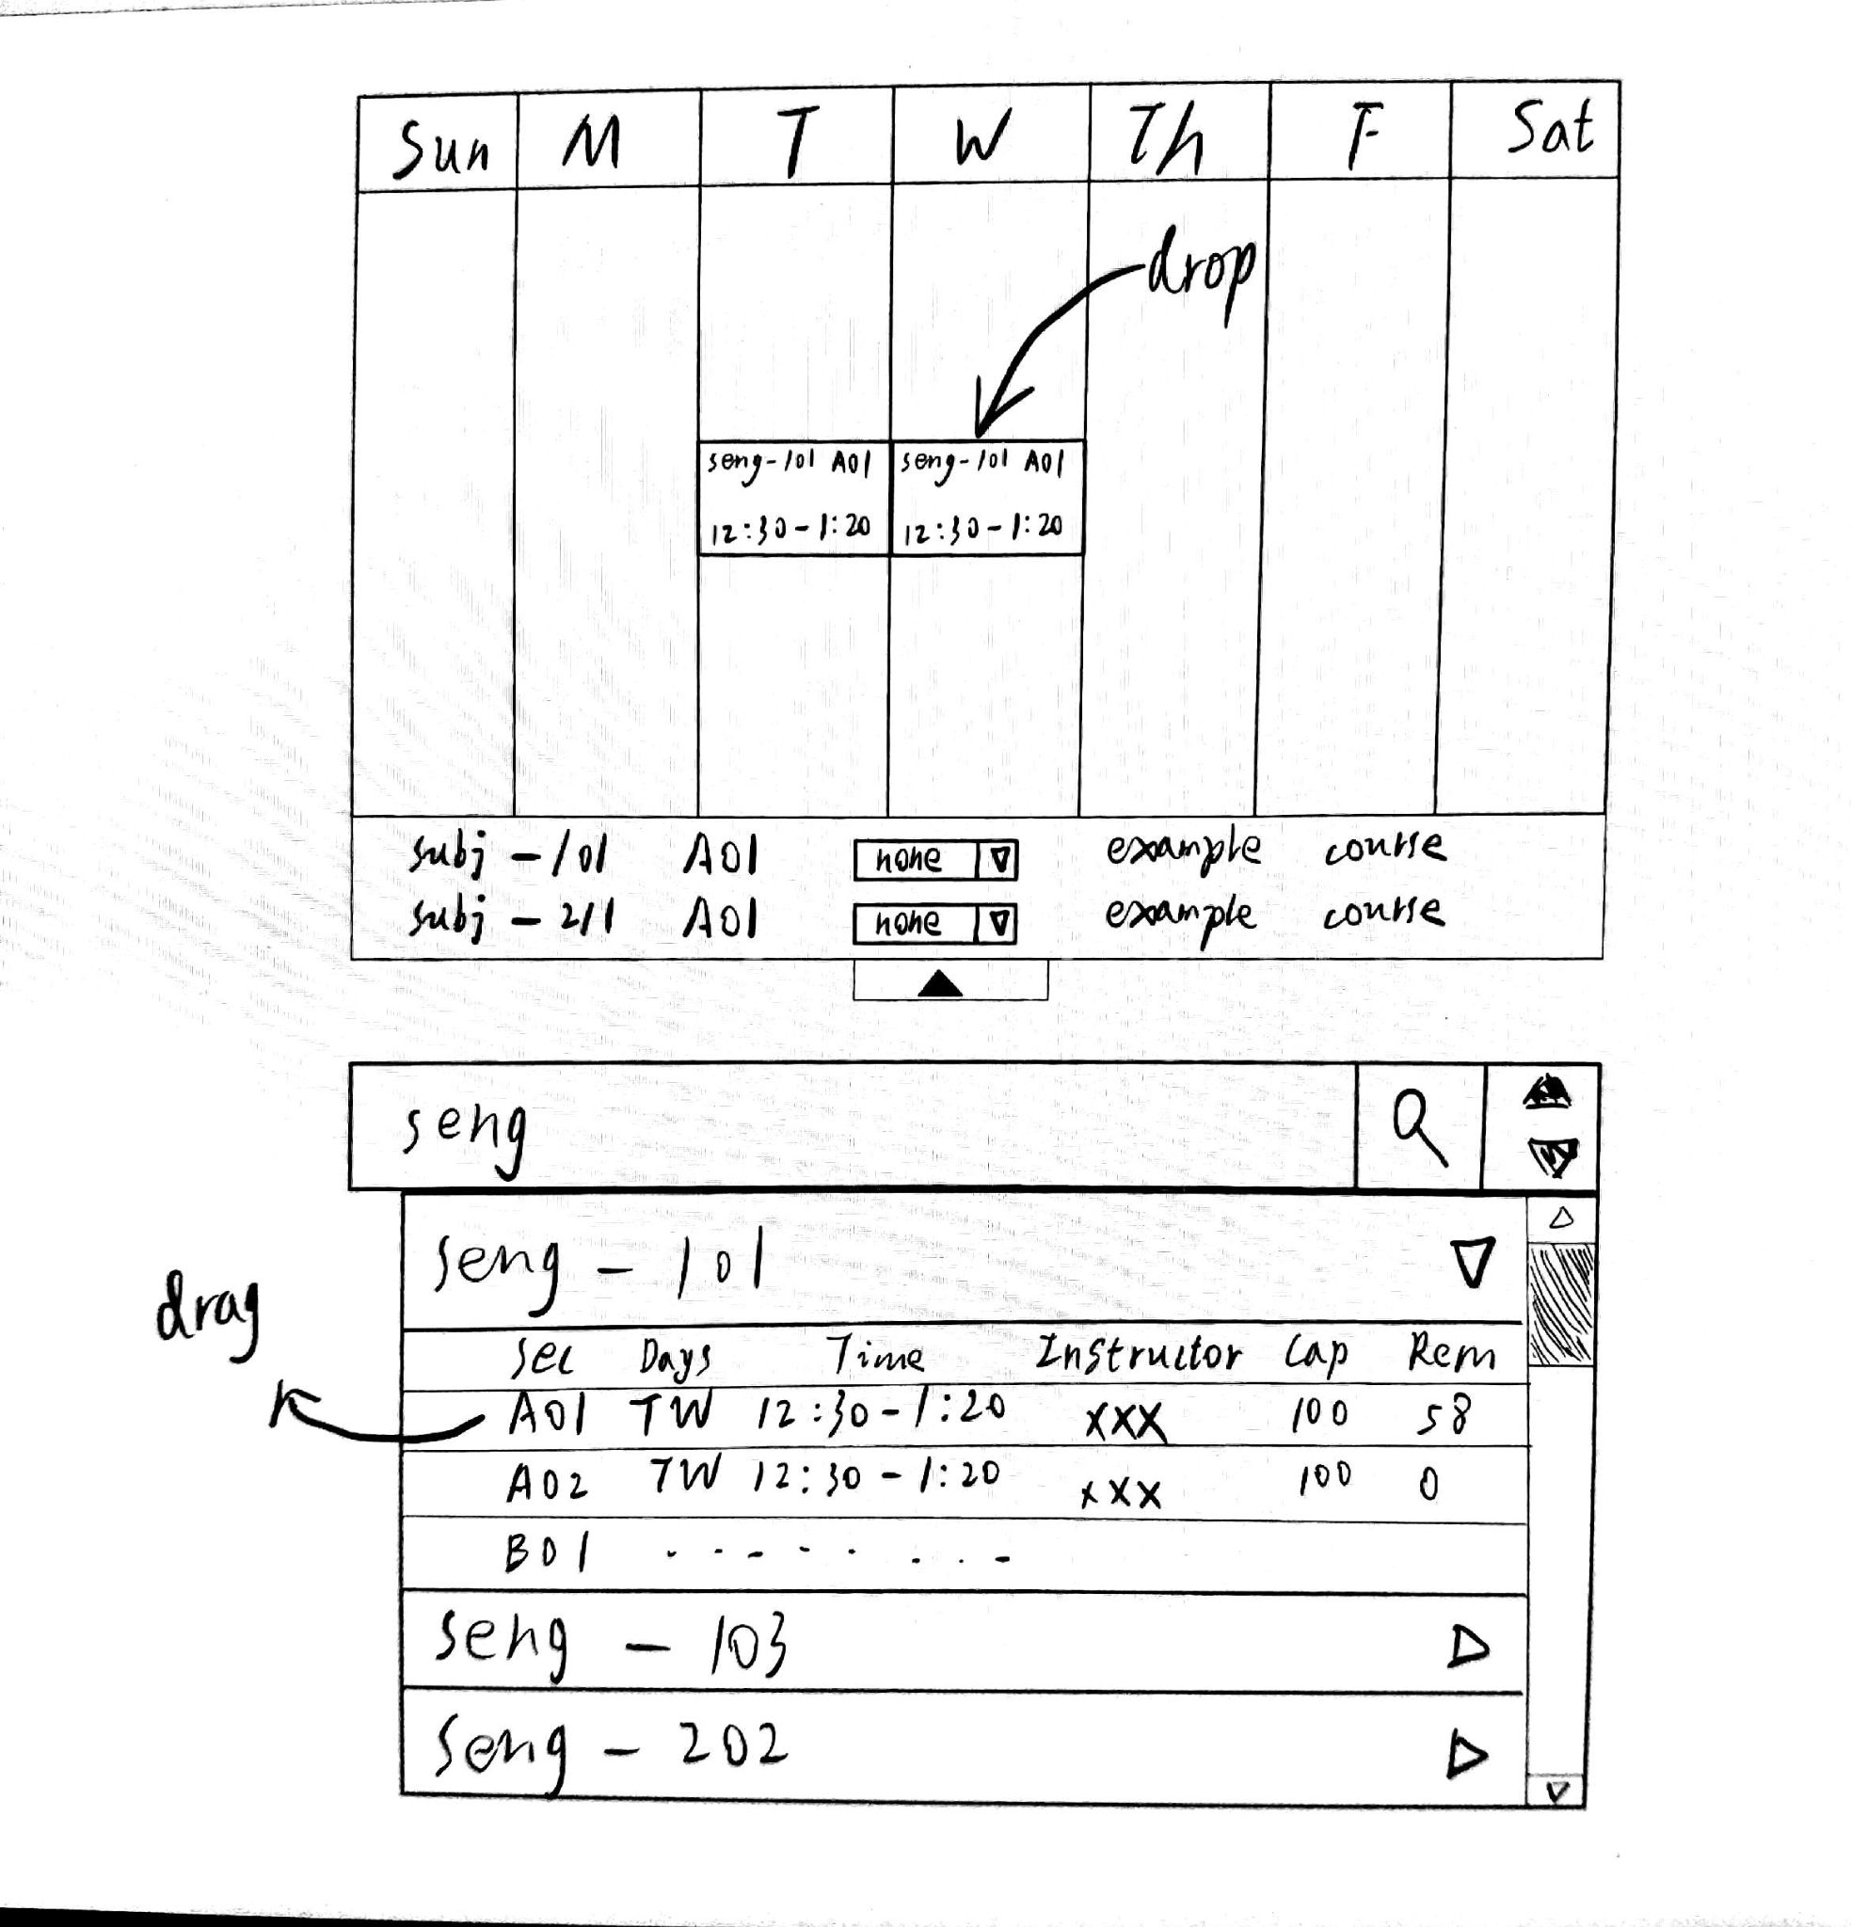

Sketch 1-1: Add/drop Overview Sketch 1-2: Drag-and-drop Overview

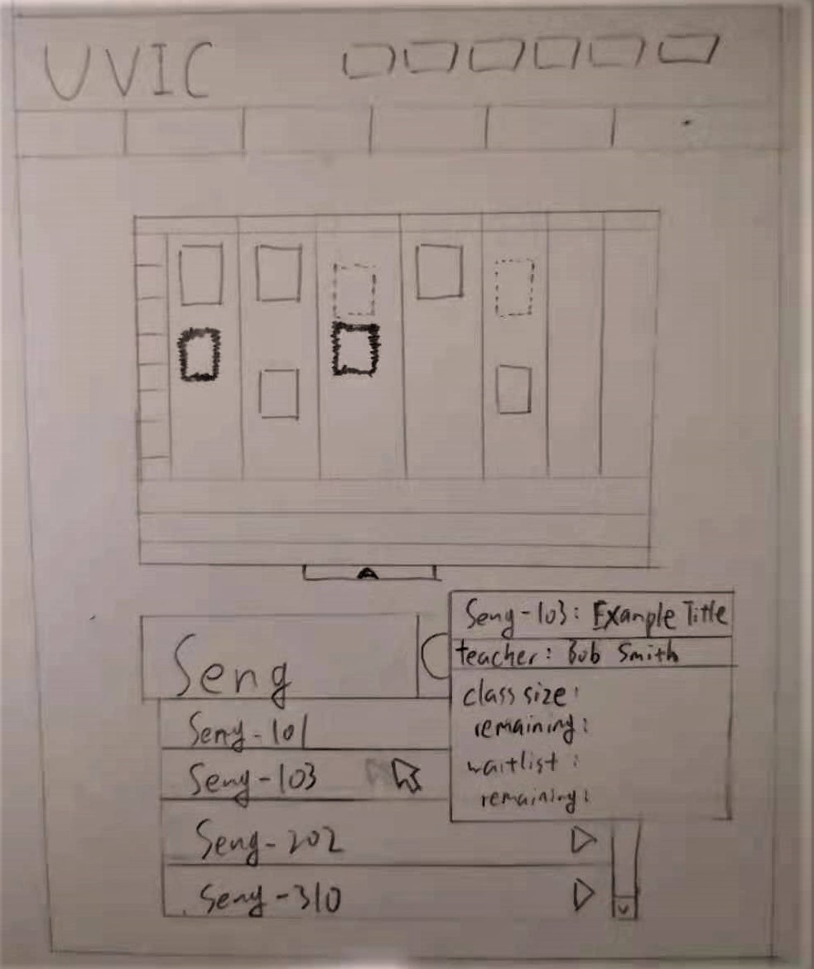 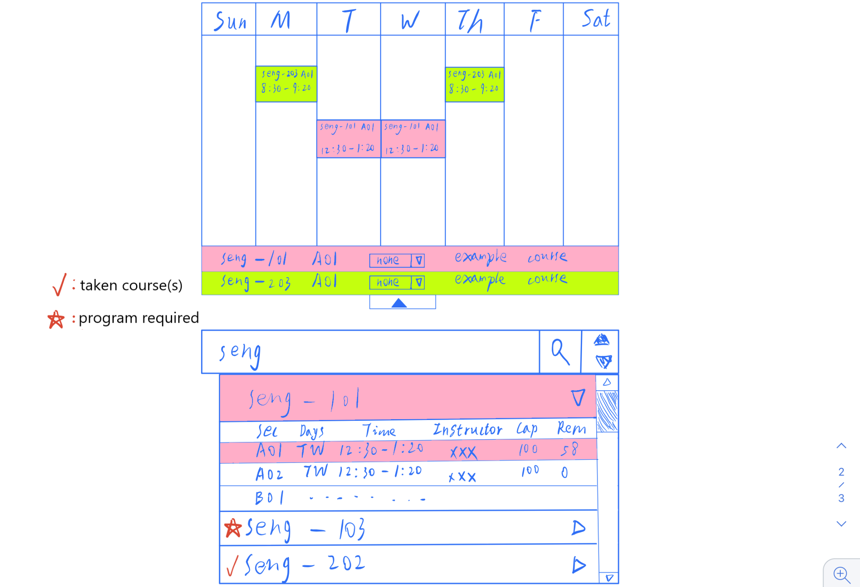

Sketch 1-3: Tooltip course information & timetable preview Sketch 1-4 Coloured timetable

Sketch 1-1 is an overview of our envisioned “add or drop” webpage. It features :

* A real time updated timetable
* Cells with solid, dashed, or animated zig-zag borders represent registered, waitlisted, and previewed courses respectively
* a list of currently registered or waitlisted courses, as a dropdown menu below the timetable
* a search bar, that supports searching a course by its course reference number (CRN), or its number (i.e. Seng-310, CSC-101 etc.)
* The arrow button beside the search bar displays a list of subjects similar to [Undergraduate calendar](https://www2.unbc.ca/calendar/undergraduate)
* A list to browse all available courses is displayed under the search bar, with each course having its own drop-down list of its lecture, lab and/or tutorial sessions.

Sketch 1-2 is a supplement to Sketch 1-1, it shows the drag-and-drop feature that is used to register a course, as well as an example search of “Seng” in the search bar.

Sketch 1-3 is a demonstration of tooltip information and timetable preview feature. When the mouse has hovered over a session for a few seconds, a tooltip shows the user the information about that session, including its number, title, instructor, class and waitlist sizes and remaining. At the same time, the timetable will show that session with an animated zig-zag border.

Sketch 1-4 displays the colours and special icon features. Users can colour-code each registered/waitlisted course, which will update both the timetable and the browsing list. The unique icons are check marks and stars, meaning already taken courses and program required courses respectively.

Conclusion:

In summary, our goal is to expand the accessibility to the Uvic course registration. The new CRS features an easily updatable timetable, more interactive tools and more precise navigation. It shortens the process of planning, selecting, and organizing courses that students often encounter.

Reference:

University of Victoria. (n.d.). Add or drop classes. UVic. Retrieved May 23, 2021,from https://www.uvic.ca/tools/student/registration/add-or-drop-classes/index.php

University of Victoria. (n.d.). Undergraduate calendar - May 2021. Uvic. Retrieved May 23, 2021, from https://www.uvic.ca/calendar/undergrad/index.php#/courses

|  |  |  |
| --- | --- | --- |
| name | task | contribution |
| Aaron Yin | Idea 1 /introduction | Came up with idea 1, worked on details with JunHong |
|  | problem | Identified the problems with current CRS |
|  | Sketches 1-1, 1-3 and descriptions | Designed the overview of the new CRS |
|  | reference | search bar inspired from https://www.uvic.ca/calendar/undergrad/index.php#/courses |
| Junhong Deng | Motivation | Collaborate idea details with Aaron |
|  | Sketch 1-2 and Sketch 1-4 | Designed some of the functionality |
|  | conclusion | Wrote the draft, revised with Aaron |
| Zhanchi Guan | Idea 2 / Problem /motivation/ solution / Sketch graph for idea2 / Reference | Came up the project idea, and expand the idea with Rui, get the first version of sketch |
|  |  |  |
| Rui Sun | Idea 2 / Problem /motivation/ solution / Sketch graph for idea2 / Reference | edited problem, motivation and solution and fix the typo of the sketch |
|  |  |  |

Table 1-1: contribution table of idea 1

这个要放在excel里

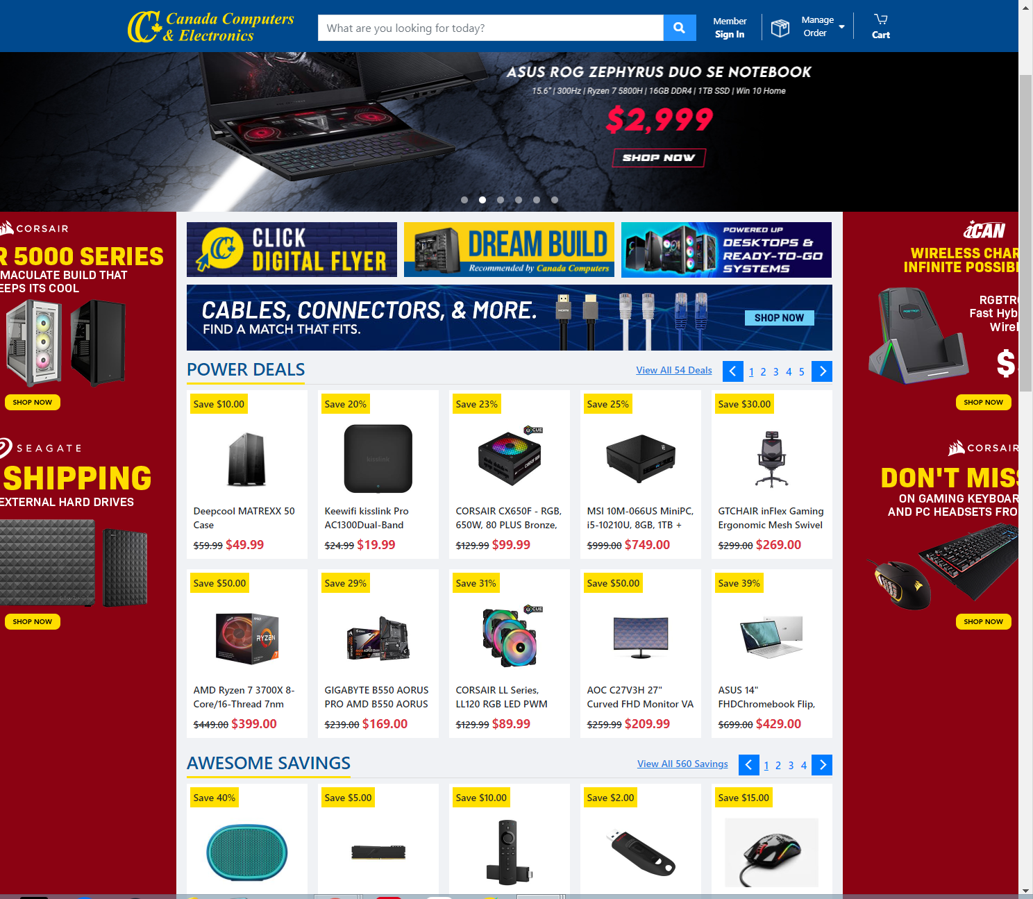figure 2-1

Problem:

The Canada Computer & Electronic website is not friendly towards those who lack professional skills on building personal computers (PC), because it does not provide clear build guides which cover systems for a variety of use-cases and budgets.

Motivation:

More and more people would like to build their own computers because people could get full control over every aspect of their build, it provides the most thorough customization options such as CPU, GPU and memory. This results in significant savings and a more efficient PC. Our ultimate aim is to develop a website that helps different types of users to select PC components effectively.

Solution:

Our solution is to develop a website based on users’ needs. When users enter the preliminary website page for the first time, they will fill a simple questionnaire (Sketch 2-1) which helps us gather users’ information effectively. Firstly, we determine whether the user is a beginner or expert at building a computer. And then, we ask for the user's purpose of building the computer, which will help us determine their needs. Lastly, we will ask the user's budget on the computer, which would help us limit the search result.

In the Sketch2-2, if the person is a beginner, we will show a step by step guiding road map to inform the user on how to construct the computer. Then we also provide a list of recommended configurations of the user's selected type. On the top of the page, there is a bar that provides the choice of “recommended, price highest to lowest and price lowest to highest” which is more convenient for novices. Users can hover the mouse over their interested build, and a tooltip will display the details and the rating of the specific build. Thus the user can find the best suitable computer configuration on the recommended list.

In the Sketch 2-3, For experts who know more about hardware information, The website provides eight categories, each allowing the user to add their preferred hardware. When the user hovers the mouse over this area, a search bar pops up to allow the user to find their preferred component in the database. After the user is satisfied with their PC the website sums up the total price(sketch 2-4).

Reference:

Amazon.sg: pc case. (n.d.). Amazon.Sg. Retrieved May 23, 2021, from https://www.amazon.sg/s?k=pc+case&crid=QQ2PKDBV9EZM&sprefix=pc%2Caps%2C448&ref=nb_sb_ss_ts-doa-p_2_2

Canada Computer & Electronic. (n.d.). Canada Computer & Electronic. Retrieved May 23, 2021, from <https://www.canadacomputers.com/>

Grey, Jess., 2021. “Want a Better PC? Try Building Your Own.” Wired, Conde Nast, www.wired.com/story/how-to-build-a-pc/.

Problem:

The Canada Computer & Electronic website is not friendly towards those who lack professional skills on building personal computers (PC) because it does not provide clear build guides that cover systems for various use-cases and budgets.

Motivation:

More and more people would like to build their computers because people could get complete control over every aspect of their build.(Grey, 2021) It provides the most thorough customization options such as CPU, GPU, and memory, resulting in significant savings and a more efficient PC. Our ultimate aim is to develop a website that effectively helps different users select PC components.

Solution:

Our solution is to develop a website based on users' needs. When users enter the preliminary website page for the first time, they will fill a simple questionnaire (Sketch 2-1) which helps us gather users' information effectively:

1. We determine whether the user is a beginner or an expert at building a computer.
2. We ask for the user's purpose of building the computer, which will help us determine their needs.
3. We will ask the user's budget on the computer, which would help us limit the search result.

In Sketch2-2, if the person is a beginner, we will show a step by step guiding road map to inform the user on how to construct the computer. Then we also provide a list of recommended configurations of the user's selected type. A bar provides the choice of "recommended, price highest to lowest and price lowest to highest", which is more convenient for novices on the top of the page. Users can hover the mouse over their interested build, and a tooltip will display the details and the rating of the specific build. Thus the user can find the best suitable computer configuration on the recommended list.

In Sketch 2-3, For experts who know more about hardware information, The website provides eight categories, allowing the user to add their preferred hardware. When the user hovers the mouse over this area, a search bar pops up to allow the user to find their preferred component in the database. After the user is satisfied with their PC, the website sums up the total price(sketch 2-4).

Introduction

The UVic course registration system (CRS), especially the “add or drop” and “timetable builder” pages, is hard to use and navigate through. It takes students a lot of time and effort to gather information and make decisions. Therefore, we aim to design a more interactive and convenient user interface for all students.

Problem:

Currently, the CRS have the following problems:

* contains too much plain text
* the search function is typically hidden
* students cannot see their timetable while looking up a course
* Requires students to have multiple tabs open, i.e. timetable, program requirements, etc.

It is hard to use and costs students too much time and effort to plan out courses in a semester.

Motivation:

Planning a semester is crucial to all students. A poorly designed CRS only complicates this process. Our goal is to reduce possible confusion caused by the current CRS and increase information gathering and course selection efficiency.

Solution:

Our solution is to design a new user interface for the CRS. The key features associated with it are convenience, clarity and efficiency. Below are some sketches of our envisioned looks of the new CRS.

Sketch 1-1: Add/drop Overview Sketch 1-2: Drag-and-drop Overview

Sketch 1-3: Tooltip course information & timetable preview Sketch 1-4 Coloured timetable

Sketch 1-1 is an overview of our envisioned “add or drop” webpage. It features :

* A real-time updated timetable
* Cells with solid, dashed, or animated zig-zag borders represent registered, waitlisted, and previewed courses, respectively
* a list of currently registered or waitlisted courses, as a drop-down menu below the timetable
* a search bar that supports searching a course by its course reference number (CRN), or its number (i.e. Seng-310, CSC-101 etc.)
* The arrow button beside the search bar displays a list of subjects similar to [the Undergraduate calendar](https://www2.unbc.ca/calendar/undergraduate).
* A list to browse all available courses is displayed under the search bar, with each course having the drop-down list of its lecture, lab and/or tutorial sessions.

Sketch 1-2 is a supplement to Sketch 1-1. It shows the drag-and-drop feature used to register a course and an example search of “Seng” in the search bar.

Sketch 1-3 is a demonstration of tooltip information and timetable preview feature. When the mouse has hovered over a few seconds, a tooltip shows the user the information about that session, including its number, title, instructor, class and waitlist sizes and remaining. At the same time, the timetable will show that session with an animated zig-zag border.

Sketch 1-4 displays the colours and special icon features. Users can colour-code each registered/waitlisted course, which will update both the timetable and the browsing list. The unique icons are checkmarks and stars, meaning already taken courses and program required courses, respectively.

Conclusion:

In summary, our goal is to expand the accessibility to the Uvic course registration. The new CRS features an easily updatable timetable, more interactive tools and more precise navigation. It shortens the process of planning, selecting, and organizing courses that students often encounter.

Idea2:

Diy computer website hard to use

Problem:

1. General diy computer hard to observe useful information (spend lots of time to built 很难收集到有用的diy信息 eg: 当你决定diy电脑后，需要逐个的查找零配件信息)
2. Easy to over price for diy computer (hard to get a total price 需要计算每一个配件的价格，没有一个完整的价格展示，需要逐个去查找 )
3. Hard to compare the hardware information(need to open multiple tabs to compare) 不能提供单一或多个配件的信息比较，或者功能性介绍 eg: 对不同需求的屏幕的参数，用途进行比较
4. 不同的人群电脑的需求也不一样

Motivation:

一些人可能想自己动手diy电脑，但是又会被繁杂的配件信息搜寻，价格比较，参数对比难倒。或者完全新手小白，不了解任何电脑硬件的基本信息，然后我们这个网站旨在介绍如何完整diy，手把手教学新手小白如何挑选电脑配件，提供傻瓜式推荐配置

Solution:

1. 我们提供了一个参考的电脑diy流程图，逐步介绍如何diy电脑，

2. 然后有完整的硬件信息展示，分8个区域分别汇总了 cpu, graphics, memory, cooling,motherboard,hard disk, PC cases, monitor 的主流产品信息介绍

3. 并且我们的每个展示的产品标有最近一个月之内的价格，可以通过添加选择的硬件计算总价

4. 网站提供单一或多个同类硬件的参数对比

(暂定 画3张图 第一张insturction 指导diy流程 第二张网站信息大类的展示 第三张俩个同类产品的对比 [q: 图中信息需要详细展示吗？] )

1. 5.20 outline写完
2. Proposal 5.22 上午之前写完 然后下午讨论一下

Proposal

More and more people would like to build their own computer since people could get full control over every aspect of their build, and also it provides the most thorough customization options from computer process unit, fans and lighting. However, it will require enough technical expertise to select and install. Therefore, we develop a website called “..” as a handy guide to walk people through it, which makes building PC much easier.

We found that many people will encounter the following problems when they build their own PC. First, users will take a lot of time to select PC components such as CPU, memory and storage. Also, it is hard to search all information for each hardware. Secondly, after selecting the hardware, you need to find the value of each selected hardware in Amazon. Then, you may need to calculate the total value by yourself. After replacing the accessories, you need to do these things again. In this process, you will waste a lot of time and energy. Thirdly, it is difficult to compare the parameter information of multiple accessories of the same type, and you may not understand the function of some parameters.

There are four solutions with respect to the issues above. In the first place, we will draw a detailed flow chart. In the diagram, we have the flow chart of DIY computer, which describes the steps of DIY computer in detail. Second, we will have each hardware information display, which has 8 parts, including the mainstream product information of CPU, graphics, memory, cooling, motherboard, hard disk, PC cases and monitor. Thirdly, we will provide the latest price of PC components along with the price history offered by different suppliers, so people will never miss the best deal. Finally, we will provide the parameter comparison of the same type of hardware products, as well as the function introduction of these performance, so that users can know a performance gap between the two products.

(你可以先看看discord我之前的那个sample，仿照covid-19 app的那个写就好了，然后下面是我想到的但是可能有点乱，你要是可以写solution就写要不我明天写也可以也可以看看上面的)

Problem:

When the general tries to get their own computer which is suitable for themself. Some people use their computer for work, some people use their computer for gaming, some people use their computer for both purposes. But building a desktop is tough because it requires people who have the knowledge to build a computer and it is difficult to find a suitable computer for specific types of people and it is hard to know different computer component information. Those would spend lots of time to open multiple tabs to compare the different computer hardware to satisfy their needs.

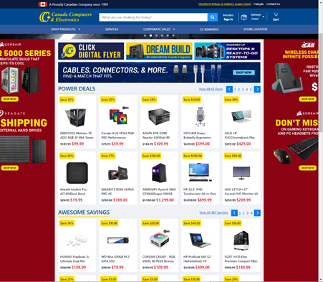

Motivation:

Some people still prefer to spend lots of time building their own suitable computer in daily life. In order to help such people to reduce time to find the appropriate computer hardware, we want to find a way to guide those people to build the computer. Currently, people find it hard to use the expected amount of value to find the suitable computer for them. Our goal is to make sure people can spend a small amount of time to find or build the appropriate computer.

Solution:

。。。。

Proposal

Problem:

We found that the Canada Computer & Electronic website does not provide a clear guide for people to find the suitable PC components, and also, it is not a friendly user interface website for the users who lack professional skills on building computer result in lack of product information such as price list and modules list for computer.

//

Problem:

We found that the Canada Computer & Electronic is not a friendly website for the users who lack professional skills on building computer, because it does not provide a clear build guides which cover systems for a variety of use-cases and budgets for users.

Motivation:

More and more people would like to build their own PC because people could get full control over every aspect of their build (Matt & Elizabeth, 2005), and also it provides the most thorough customization options such as CPU, GPU and memory. This can result in significant saving and more efficient computer. Our goal is developing a website that would take less time to get the possible option for people who lack professional skills for building their own computer.

//Motivation:

More and more people would like to build their own PC because people could get full control over every aspect of their build (Matt & Elizabeth, 2005), and also it provides the most thorough customization options such as CPU, GPU and memory. This can result in significant saving and more efficient computer. Our ultimate aim is to develop a website that will help different type of users select PC components effectively.

Solution:

Our solution is to develop a website based on the data on various building computer websites. It is designed as entering the preliminary website page, we will ask a few simple questionnaires for users. For example, asking whether the user is a novice or veteran to construct a computer, and then we need to know the user's purpose is for building the computer, which will help us determine their needs. Lastly, we will ask user’s expect value spending on the computer which would help us reduce the search result.

//Our solution is to develop a website based on different user’s needs. when users enter the preliminary website page for the first time, they will have simple questionnaires which help us gather users’ information effectively. Firstly, we could determine whether the user is a beginner or expert to building computer. And then, we could know the user's purpose of building the computer, which will help us determine their needs. Lastly, we will ask user’s expected value spending on the computer, which would help us reduce the search result.

In the Sketch2a, If the person is beginner, we will show the guiding road map to instruct the user how to step by step to construct the computer. After showing user how to construct their computer, we also provide the recommended configuration for such type of users. On the top have the bar can choice “recommended, price highest to lowest and price lowest to highest” which is more convenience for novices. User can drag to the interested recommendation, they will see the computer hardware specific detail and the rating of this computer. Then user can base on their needs to find the best suitable computer configuration list on this website.

//

In the Sketch2a, If the user is a beginner, we will provide a build map in order to guide them step by step and ensure that the building process goes smoothly. We will also provide reasonable solution to building their own PC after users know the entire building process. On the top of the website, there are recommended solution, price highest to lowest and price lowest to highest, which will be more convenient for beginners to find their desirable building list. And also, beginners could clearly know the information of PC hardware and the rating of the PC that they are interested in, so that users could find the suitable PC component list on this website based on their needs.

In the Sketch 2b, For expert who know more about hardware information, We'll provide a page with eight small areas, each area allows users to add the preference hardware. When user drag to this area it will pop the small search bar to allow the user to find the expected computer component in our database. After user build their personal computer we can help them to quote the price for this computer.

。。。。

reference

https://www.researchgate.net/publication/228577088_Doing_it_yourself_Products_competence_and_meaning_in_the_practices_of_DIY

图片

<https://www.amazon.sg/s?k=pc+case&crid=QQ2PKDBV9EZM&sprefix=pc%2Caps%2C448&ref=nb_sb_ss_ts-doa-p_2_2>